**Smart SDLC** **- AI-Enhanced**

**Software Development Life Cycle**

**Team leader:**  S. Indhu

**Team member:** V.Mohana

**Team member:** M. Kirthika

**1.Introduction**

The Software Development Life Cycle (SDLC) is a systematic process used to design, develop, test, and deploy software solutions. Traditional SDLC models provide a structured framework that ensures efficiency, quality, and predictability in software projects. However, with the growing complexity of applications and the demand for faster delivery, traditional methods face challenges in maintaining speed, accuracy, and adaptability. This has led to the evolution of smarter approaches that integrate automation, advanced tools, and intelligent systems to enhance the overall development process.

Smart SDLC, powered by Artificial Intelligence, represents a new generation of software engineering practices where intelligent algorithms and automation assist developers at every stage. AI tools can predict potential risks, optimize coding practices, identify bugs early, and even suggest design improvements. By analyzing vast amounts of data and learning from past projects, AI enhances decision-making, reduces errors, and accelerates development timelines. This intelligent augmentation not only improves productivity but also helps organizations deliver more reliable and scalable software solutions.

The integration of AI into SDLC is a step toward creating adaptive, self-improving systems that evolve with project requirements. Smart SDLC enables real-time monitoring, continuous testing, and predictive maintenance, making the software lifecycle more efficient and sustainable. It bridges the gap between human expertise and machine intelligence, ensuring that development teams can focus more on creativity and innovation while repetitive tasks are automated. Ultimately, Smart SDLC transforms software development into a more agile, intelligent, and future-ready process.

**2.Project Overview**

◇ **Purpose / Goal**

The purpose of Smart SDLC is to revolutionize the traditional software development process by integrating Artificial Intelligence into every stage of the lifecycle. Its primary goal is to enhance efficiency, accuracy, and speed, addressing the challenges faced in conventional models. By automating repetitive tasks and enabling data-driven decision-making, Smart SDLC ensures that projects are completed within shorter timelines while maintaining high quality.

Another important goal is to improve risk management and error detection throughout the development journey. AI-powered insights allow developers and project managers to anticipate challenges early, thereby reducing costly delays and failures. This not only saves time and resources but also increases the reliability and security of the final product.

The project also aims to support innovation by reducing the manual burden on developers, giving them more time to focus on creativity, problem-solving, and advanced features. Ultimately, Smart SDLC strives to create a sustainable, adaptive, and future-ready approach that aligns with modern software demands and industry standards.

◇ **Features**

Smart SDLC offers advanced automation across different stages of development, including requirement analysis, coding, testing, and deployment. AI-powered tools streamline workflows by generating intelligent suggestions, code snippets, and bug fixes, thereby reducing manual effort and human error. This feature not only enhances productivity but also accelerates project delivery without compromising on quality.

Another key feature is predictive analytics and real-time monitoring. The system can track progress, analyze patterns, and forecast potential issues before they become critical. Continuous integration and continuous testing, powered by AI, ensure that software remains stable and scalable throughout the lifecycle. This makes Smart SDLC a proactive framework that adapts to dynamic requirements.

Additionally, Smart SDLC provides intelligent documentation, knowledge management, and self-learning capabilities. It evolves with each project, gathering insights from previous outcomes to improve future development cycles. By combining automation, adaptability, and continuous improvement, these features transform the software development process into a more reliable, intelligent, and sustainable practice.

**3.Architecture**

The architecture of Smart SDLC is designed to seamlessly integrate Artificial Intelligence into every stage of the software development process. It follows a layered design where each module interacts intelligently, ensuring smooth transitions between planning, development, testing, and deployment. The architecture prioritizes scalability, flexibility, and real-time adaptability, enabling the system to evolve as requirements change.

AI algorithms are embedded into the pipeline to analyze requirements, suggest designs, detect bugs, and improve performance. This architectural design supports continuous integration and continuous delivery (CI/CD), allowing teams to release updates frequently without disruptions. Data-driven insights guide decision-making, ensuring that development follows the most efficient path.

In addition, the architecture supports cloud-based deployment, making it accessible, secure, and collaborative. By leveraging machine learning models, predictive analytics, and automated testing frameworks, the architecture creates a robust foundation for future-ready software development. This design ensures that Smart SDLC can handle complex projects while reducing manual effort and errors.

**4.Setup Instructions**

Setting up Smart SDLC involves preparing both the development environment and the AI-assisted tools required for the project. Users need to install basic dependencies such as programming languages, package managers, and AI libraries before starting the workflow. Proper configuration ensures that the system can run smoothly across different platforms.

A guided installation process helps developers connect with APIs, set up database integration, and configure AI-powered modules. Each step in the setup is automated as much as possible to minimize errors and ensure that developers can start working without lengthy preparations. Clear instructions and documentation make it beginner-friendly, even for those new to AI-based workflows.

The setup also ensures secure authentication, role-based access, and environment-specific configurations. By combining simplicity with automation, Smart SDLC’s setup process reduces overhead while ensuring that all required tools, frameworks, and models are correctly integrated. This prepares the system for immediate use in software development projects.

**5.Folder Structure**

The folder structure of Smart SDLC is organized to ensure clarity, modularity, and easy navigation. Each folder is categorized based on functionality, such as code, configuration, documentation, and testing. This structured approach improves team collaboration and makes debugging and maintenance more efficient.

Source code is separated into modules representing different stages of SDLC, ensuring that AI-assisted tools are mapped clearly within the project. The structure also includes dedicated directories for datasets, machine learning models, and output logs. Such organization allows developers to quickly identify files and reduce confusion.

In addition, the folder structure supports scalability, meaning new features and modules can be added without disrupting existing workflows. This modular approach makes Smart SDLC flexible and easier to extend for future enhancements, aligning with best practices in software engineering.

**6. Running the Application**

Running the Smart SDLC application requires initializing the environment and executing the main program file. Once dependencies are installed, the application can be started using simple commands or scripts that activate AI-powered modules. This process ensures that users can begin interacting with the system seamlessly.

The application provides a guided interface where users can input requirements, track progress, and monitor AI-generated insights. Background processes continuously analyze data, optimize code, and suggest improvements while the system runs. This creates an interactive and intelligent development experience.

Additionally, Smart SDLC supports real-time monitoring of workflows, allowing developers to check performance, track bugs, and test features during execution. By combining automation with active monitoring, the application ensures both speed and reliability in delivering results.

**7.API Documentation**

The API documentation in Smart SDLC provides detailed guidance on how developers can interact with the system. Each endpoint is described with its purpose, required parameters, response formats, and example usage. This ensures smooth integration with external systems and third-party tools.

The documentation highlights AI-driven endpoints that automate requirement analysis, code generation, bug detection, and testing. Clear examples are provided to help developers understand how to make requests and handle responses effectively. This ensures that even beginners can work with the system’s APIs without confusion.

Comprehensive API documentation not only enhances usability but also promotes reusability of components. Developers can extend existing APIs, integrate with cloud platforms, and customize functionalities to match project needs. This makes Smart SDLC a flexible and developer-friendly solution.

**8.Authentication**

Authentication in Smart SDLC is designed to ensure secure access and protect project data. The system implements role-based authentication, allowing only authorized users to access specific modules and features. Strong encryption and secure token mechanisms safeguard against unauthorized access.

AI-driven monitoring adds an additional layer of security by detecting unusual login patterns or suspicious activities. The system can adapt security measures dynamically, ensuring that threats are identified and neutralized in real time. This makes the authentication process both intelligent and reliable.

User-friendly authentication methods, such as single sign-on (SSO) and multi-factor authentication (MFA), are also supported. These mechanisms balance convenience with security, ensuring that the Smart SDLC environment remains both safe and accessible to developers.

**9.User Interface**

The user interface of Smart SDLC is designed to be simple, intuitive, and interactive. Developers can easily navigate between different stages of the lifecycle, from planning to deployment, through a clean dashboard. The UI highlights AI-driven suggestions and analytics, making them accessible at a glance.

Visualization tools within the interface provide real-time insights into progress, performance, and potential issues. Graphs, charts, and dashboards help teams understand complex data quickly, improving decision-making. This enhances collaboration and transparency within the team.

The interface is also customizable, allowing users to tailor it according to their roles and preferences. Whether a developer, tester, or project manager, each user can access the tools most relevant to their work. This adaptability ensures an efficient and user-friendly experience.

**10.Testing**

Testing in Smart SDLC refers to the process of evaluating software modules to ensure they meet functional, performance, and security requirements. It is one of the most critical phases in the development lifecycle because it validates that the application works as intended and delivers accurate results. By integrating AI into testing, Smart SDLC reduces manual effort and improves the accuracy and speed of defect detection. This ensures higher reliability and quality in the final product.

In this project, testing is not limited to traditional functional checks but also includes AI-powered automation, predictive analytics, and continuous testing. Automated scripts check for bugs, errors, and vulnerabilities across modules, while AI algorithms analyze historical test data to forecast potential issues. This proactive approach helps prevent failures before they reach the deployment stage.

Testing within Smart SDLC also covers multiple types, such as unit testing, integration testing, regression testing, performance testing, and security testing. Each type ensures that specific aspects of the application are validated. Together, these testing practices guarantee that the software is scalable, efficient, and secure. With AI-enhanced Smart SDLC, testing becomes more dynamic, adaptive, and reliable compared to traditional methods.

**11.Future Enhancement**

Future enhancements of Smart SDLC aim to expand automation and adaptability even further. One of the main areas of improvement is integrating more advanced machine learning models to provide deeper insights and predictive capabilities. This will allow the system to suggest solutions for complex problems more accurately.

Another planned enhancement is the integration of natural language processing (NLP) to understand project requirements directly from plain text or voice commands. This will simplify requirement gathering and make Smart SDLC even more user-friendly.

In addition, future versions will focus on advanced cloud integration, blockchain-based security, and enhanced collaboration tools. These improvements will ensure that Smart SDLC remains at the forefront of intelligent software development practices.

**12.Conclusion**

Smart SDLC demonstrates the power of AI in transforming traditional software development practices. By embedding intelligence into every stage of the lifecycle, it addresses the challenges of speed, quality, and adaptability that modern projects demand. It makes development more efficient and sustainable for organizations.

Through automation, predictive analytics, and intelligent insights, Smart SDLC reduces errors and improves overall productivity. It ensures that projects are not only delivered faster but also meet higher standards of reliability and security. This makes it an essential approach for the future of software engineering.

The conclusion emphasizes that Smart SDLC is not just a framework but a shift toward intelligent, adaptive, and innovative development processes. It prepares the software industry for evolving challenges while encouraging teams to focus more on creativity and strategic decision-making.

**13.Source code Implementation**

**Step 1:** Import required libraries and set up authentication for AI model integration.

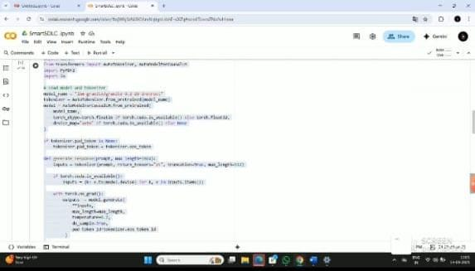

**Step 2**: Define tokenization and input data preparation for model processing.

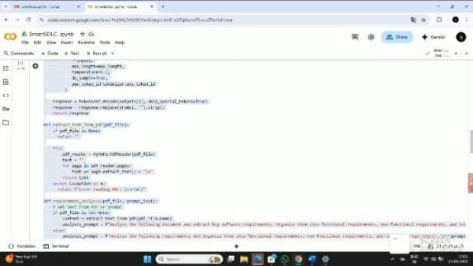

**Step 3:** Generate structured response using the AI model and display output via the interface.

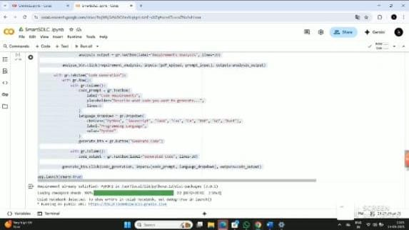

**14.Output**

Display the generated analysis output with requirements and functional specifications in a structured format.

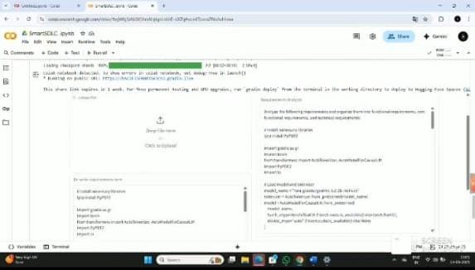

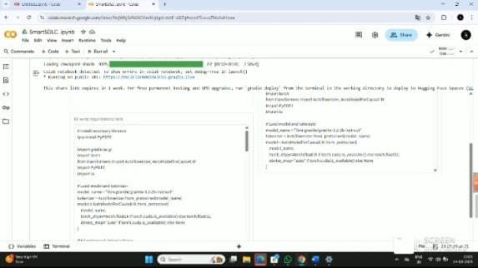

**15.Reference**

The references for Smart SDLC include research papers, technical articles, and documentation on AI-driven software development. These resources provide insights into best practices, case studies, and tools that inspired the creation of Smart SDLC. They ensure that the project is grounded in established knowledge while contributing new ideas.

Industry documentation from AI frameworks, cloud service providers, and open-source communities also forms a part of the reference material. These sources help in understanding the integration of advanced technologies into software lifecycles.

By acknowledging references, Smart SDLC highlights its foundation on proven techniques while aiming to innovate beyond existing solutions. This ensures credibility and transparency in its development.